Peek at Our Week
Standard Focus | Activity | Home Extension Activity
- Uses various drawing and art tools with developing coordination | 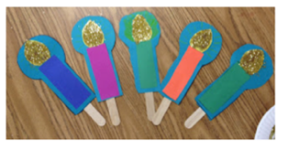  ”This Little Light of Mine” Song Props | The lyrics to this song are on the back of this paper and a video with our Easter songs are on our school’s website.
- Uses senses to observe and experience objects and environment  - Uses tools in scientific inquiry | Experimenting with Flashlights: Transparent  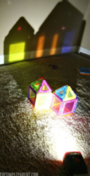 | Flashlights are fun to use to explore. Put them into transparent plastic cup or put transparent paper over the light to produce different colors. Put the flashlight under a colander to create a “starry night” on your ceiling. Make shadows with your hands. Use one with your MagnaTiles. Build a structure with blocks and then shine a light behind it to see the reflection on the wall. Use your imagination and have fun with light!
Experimenting with Flashlights: Solid
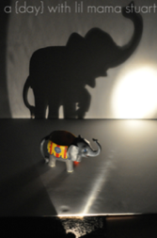
Parent Resources: Learning that Jesus is the Light of the World is the focus for this week.

