Peek at Our Week
Standard Focus | Activity | Home Extension Activity
- Shows an understanding of words and their meanings (receptive)  - Begins to demonstrate understanding of age-appropriate vocabulary across multiple topic areas and demonstrates a variety of words and their meanings within each area (e.g., world knowledge, names of body parts and feelings) | 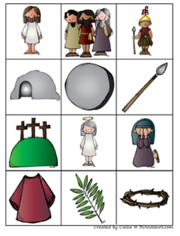  Easter vocabulary game | Building your child’s vocabulary can be fun. Most young children love to say and use big words. Instead of telling you child what the did was “great”, say that it’s “fantastic”, “gorgeous”, magnificent”, or “superb”. Have fun with language and your child will have a tremendous vocabulary which will help them when they learn to read and write.
- Demonstrates increasing precision, strength, coordination and efficiency when using hand muscles for play and functional tasks | 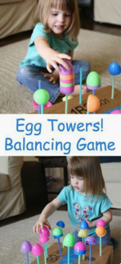 | Easter eggs are very inexpensive, and children love to play with them. As you can see in these pictures, they can be used for balancing and stacking and pattern making. But the uses are endless: sorting by colors, hiding objects inside, counting, matching, etc. You can write number or letters on the eggs for matching numbers and the corresponding number of dots or matching upper case to lower case letters. So, get how those plastic eggs early this year and have a wonderful time learning with your children.
- Notices a pattern with a missing object and completes the pattern by filling in the missing object | Easter egg pattern making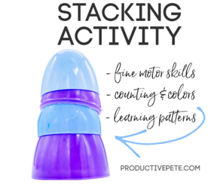
Parent Resources: For the next 7 weeks, we will be learning about the life, death, burial and resurrection of Jesus Christ. This week’s focus will be on learning the events of the Easter story.

