Peek at Our Week
Standard Focus | Activity | Home Extension Activity
- Responds to and expresses opinions and feelings about own art form as well as a variety of artistic expressions of others | 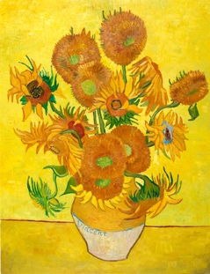  Van Gogh’s Sunflowers  The children will be using flowers as stamps to recreate this famous painting. | Take a trip to a florist or floral department of the grocery store, Hobby Lobby or even Dollar Tree and look at all the colors, textures and shapes of the flowers. Maybe allow your child to buy one of their favorite flowers to bring home.
- Increasingly coordinates hand and eye movements to perform a variety of actions with increasing precision  - Uses hand-eye coordination to manipulate objects and materials (e.g., completing large-piece puzzles or threading beads with large holes, begins to use scissors) | Tear pieces of yellow tissue paper and glue on to paper | Tearing paper builds fine motor coordination. Give your child your junk mail and let them tear it up and put it in the trash. They will love this activity.
- Describes what objects are used for and is able to express ideas (e.g., names some colors, shapes, and says full name)  - Begins to demonstrate knowledge of verbal conversational rules (e.g., appropriately takes turns, does not interrupt, uses appropriate verbal expressions and uses appropriate intonation) | Using salt trays have the children use a small paint brush to search for yellow objects. Sort into yellow or not yellow sets. | Making a salt tray for home play is easy and lots of fun for your child to explore. Check out Adventures and Play for an example.
Parent Resources: For the next 6 weeks, we will be learning about and exploring colors. The children will be introduced to a painting from a famous artist and then given a chance to recreate the painting using different techniques. The first piece of art work which they will be exploring in Vincent van Gogh’s, Sunflowers This week we will be concentrating on the color yellow. Each day we will be hunting for the color yellow on the children’s clothing.

