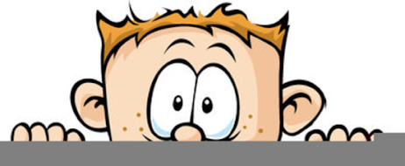

Peek at Our Week
Standard Focus | Activity | Home Extension Activity
- Demonstrates directionality, order and position of objects by following simple directions  - Uses size words to label objects  - Represents ideas and observations through drawings or using other forms of representation (e.g., manipulatives or different objects) | Ani Hoover’s Green Spring  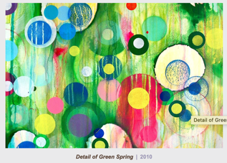  The children will first use green watercolor paint to make the background and then stamp brightly colored circles on top. | Stamping with circles can be easy and fun at home. Toilet paper and paper towel rolls work well as circle stamps. Sponges can be cut into different size circles. Oranges, lemons or limes could also be used. Just use your imagination and have fun.
- Participates in group sorting and data collection | Arrange paint chips from light to dark shade. | Paint chips from your local home improvement store are not only free but fun to use for art projects. Go pick up some different colored strips and have your child cut them apart and glue onto a piece of construction paper.
- Increasingly coordinates hand and eye movements to perform a variety of actions with increasing precision  - Makes simple predictions and reflects on what caused something to happen  - Participates in and discusses simple experiments  - Demonstrates the use of simple tools and equipment for observing and investigating (e.g., droppers, blocks, bug catchers) | Coloring mixing with eye droppers and watercolors | Bath time is a great time to do color mixing. You can use food coloring but don’t make the color to strong or it could cause stains. Colored bath tablets can be purchased at Walmart and other stores. Make one yellow, one blue and one red cup. Provide some extra cups to use for mixing. Give your child a turkey baster, eye dropper or spoons and let them explore mixing the colors.
Parent Resources: The color of the week is green. They will be learning that mixing yellow and blue makes green.

