Peek at Our Week
Standard Focus | Activity | Home Extension Activity
- Demonstrates directionality, order and position of objects by following simple directions  - Uses size words to label objects | Piet Mondrian  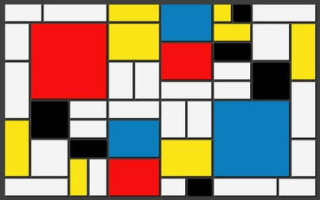  The children will be given squares and rectangle in the primary colors and black to glue onto white paper to make their representation of this painting. | If you have not introduced your child to scissors, now is the time. Here are some fun tips and hacks to help your little ones practice their scissor skills:  - Start with “snipping”. Practicing small snips will help promote practice, as well as success!  - Using a more restrictive paper such as cardstock or thicker paper can help with control (much easier to hold the paper steady than flimsy paper or thin material). You can also steady the paper for them to reduce the amount of work and coordination.  - Teaching “thumbs up” when holding the scissors by placing a small sticker or Washi tape to remind them which side is up – tell them to make sure they can see their sticker.  - When teaching the forward motion aspect, make it fun! Pretend like the scissors are alligators, trains, cars, etc and have them cut across a path or road.
- Participates in group sorting and data collection | Sort buttons into color coded buckets | 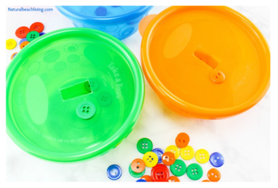  Here’s another site to check out for a fun button sorting activity. Natural Beach Living
- Participates in group sorting and data collection  - Increasingly coordinates hand and eye movements to perform a variety of actions with increasing precision | String red, blue and yellow beads onto corresponding color pipe cleaners | Try this fun stringing activity, stringing Cheerios or Fruit Loop cereals onto a pipe cleaner or string.
Parent Resources: Red is the color for the week.

