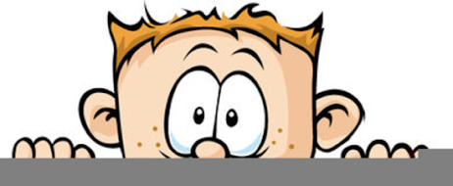

Peek at Our Week
Standard Focus | Activity | Home Extension Activity
- Represents ideas and observations through drawings or using other forms of representation (e.g., manipulatives or different objects) | Van Gogh’s Starry Night  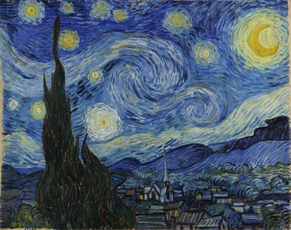  The children will be using fingerpaint, forks and sponges to make their representation of this famous painting. | Take some time this week to go outside and look at the stars.
- Participates in group sorting and data collection  - Describes what objects are used for and is able to express ideas (e.g., names some colors, shapes, and says full name) | Sort nature pictures by color | Take some time this week to notice the colors in nature. Take a walk around your yard and see how many different colors you can find. When cooking and eating dinner, discuss the colors of the foods.
- Describes what objects are used for and is able to express ideas (e.g., names some colors, shapes, and says full name) | The sensory bin will be filled with a different type of pasta dyed to the color of the week. | Dying pasta is very easy. Dump a box of pasta into a gallon zip-lock plastic bag. Then add a few teaspoons of rubbing alcohol and several drops of food coloring. Finally shake the bag until the pasta is the desired color and pour it onto a cookie sheet to dry. Put the dried colored pasta into a bin and give your child some cups, spoons, empty water bottles, etc and let them have fun.
Parent Resources: The color for this week is blue.

