Peek at Our Week
Standard Focus | Activity | Home Extension Activity
- Demonstrates directionality, order and position of objects by following simple directions  - Responds to and expresses opinions and feelings about own art form as well as a variety of artistic expressions of others | Jackson Pollock  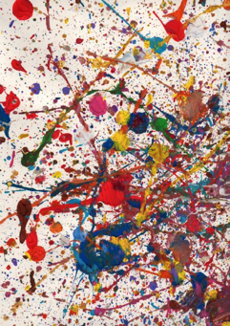  The children will splatter and spray paint on a large painter’s drop cloth outside | Painting like Jackson Pollock is fun but can also be very messy. Here’s a relatively neat way to achieve the same look: painting with yarn! Cut any color yarn into 6 inch pieces, one for each color of paint you intend on using. Put the paint onto paper plates and put a piece of yarn into each color. Either using your fingers or a clothes pin pick up the yarn and drag or stamp in on the paper.  Watch this video to see it done: Yarn Painting (https://www.youtube.com/watch?v=_iHFLUwh43M)
- Makes simple predictions and reflects on what caused something to happen  - Participates in and discusses simple experiments  - Responds to and expresses opinions and feelings about own art form as well as a variety of artistic expressions of others | Watercolor paint on a coffee filer with red and blue paint to create purple | Coffee filter papers are fun to paint on because the paint spreads out. Give your child a coffee filter which is set on a cookie sheet. If you don’t have watercolor paints, just add a few drops of food coloring to water or use bath color tabs. Q-tips, as the brush, work great for this project.
- Begins to recognize nutritious food choices and healthy eating habits | “Eat the Rainbow”  Valentine’s Day Party | A fun way to do this at home is to use an ice cube tray. Fill each hole with different colored foods for a “Rainbow Snack!”  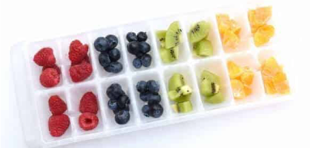
Parent Resources: The color we will be learn about is purple. They will be discovering that mixing red and blue makes purple. Friday we will be celebrating Valentine’s Day with an “Eat the Rainbow Party” and passing out Valentine cards. See the attached letter for details.

