Peek at Our Week
Standard Focus | Activity | Home Extension Activity
- Begins to explore a greater variety of motions with objects (e.g., rotate, spin, twist)  - Demonstrates ability to self-regulate | MagnaTile Christmas Tree Activity  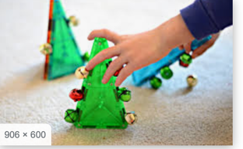 | 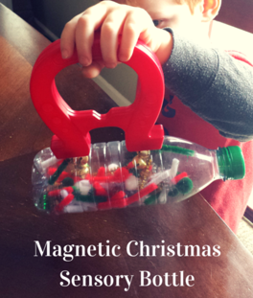  Magnets are so much fun for children to use to explore their world. Put jingle bells (Available at the Dollar Tree) and small pieces of pipe cleaner and put them in an empty plastic bottle. Run a magnet up the side of the bottle to catch the jingle bells.
- Learning about Jesus and the Christmas Story  - Asks questions, and responds to adults and peers in a variety of settings  - Asks and responds to simple questions (e.g., “Who?” “What?” “Where?” “Why?”) using gestures and two- or three-word phrases in back-and-forth exchanges | Christmas Story Sequencing Cards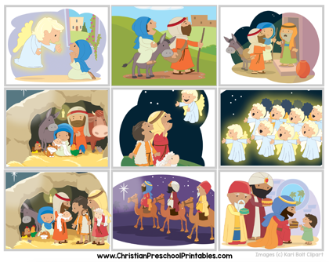 | Christmas time and become very busy but try to carve out some time in your schedule to remember to celebrate the birth of Christ. Read stories. Play with a nativity set. Act out the story of His birth. Sing songs which tell the story and celebrate His birth.
- Begins to explore a greater variety of motions with objects (e.g., rotate, spin, twist)  - Demonstrates ability to self-regulate  - Begins to describe, compare, sort and classify objects based on observable physical characteristics (e.g., color, sound, weight) | Loose Parts Christmas Tree Activity  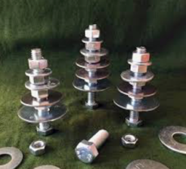 | “Loose Parts” is a term used for presenting children with a variety of materials and allowing them to explore, build, manipulate, sort with no pre-determined result. In the Christmas Tree activity, the children will to shown how to make a tree, but they will not be required to make a tree. On the back of this sheet, I have printed an article about “Loose Parts Play”.
Parent Resources: I have attached a laminated sheet with the characters to create your own Nativity scene which your family can enjoy. Just cut out each image and glue or tape them to boxes, blocks, or craft sticks.

