Peek at Our Week
Standard Focus | Activity | Home Extension Activity
- Begins to explore a greater variety of motions with objects (e.g., rotate, spin, twist)  - Demonstrates increasing precision, strength, coordination and efficiency when using hand muscles for play and functional tasks  - Coordinates the use of hands and fingers |  | Christmas time is a great time to string items. String beads or bells for your tree or as a garland.
- Demonstrates use of large muscles for movement, position, strength and coordination | Play “Packing and Pushing/Pulling Santa’s Sled” | Heavy work is important for the development of your child’s large muscles. I have printed a list of “heavy work” activities for your child to do at home.
- Counts and identifies the number sequence “1 to 10”  - Plays, works and prays happily with others. | Roll and Cover Santa’s Beard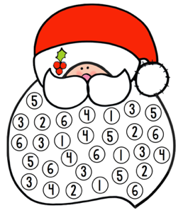  The child will roll and dice and then cover the corresponding number on Santa’s beard. | Christmas time lends itself to counting at home. Have your child count the presents under the tree, the cookies you just baked, the stocking hanging waiting for Santa, the opportunities are endless. Also, children love rolling dice. Have them roll a dice and then find that many cars, dolls, or blocks. Have fun counting your way through Christmas!!
Parent Resources: Heavy work handout attached.

