Peek at Our Week
Standard Focus | Activity | Home Extension Activity
- Begins to explore a greater variety of motions with objects (e.g., rotate, spin, twist)  - Demonstrates comprehension of meaning of text via pointing to pictures, responding to conversations | Christmas Puzzles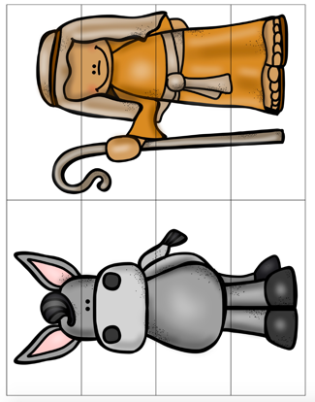 | Any picture can be turned into a puzzle. Old Christmas cards work great. Just cut the card into strip and have your child try to put it back together. Family photos make fun puzzles too.
- Increases knowledge through listening  - Responds to an adult’s simple questions about what is being learned  - Asks questions, and responds to adults and peers in a variety of settings  - Asks and responds to simple questions (e.g., “Who?” “What?” “Where?” “Why?”) using gestures and two- or three-word phrases in back-and-forth exchanges | Roll and Graph Nativity Game  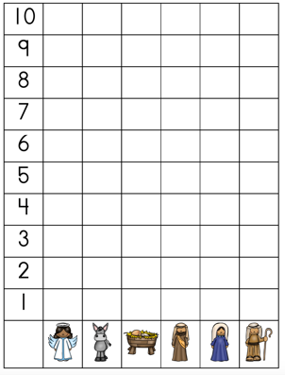 | The children roll a dice with the images on it. They place a counter in the corresponding column. When one column reaches 10, the game is over. The children love this game. They can play it with another child or alone. This type of game can be made easily at home. You could take small pictures of your family and place them on a table. You can tape your pictures on anything which is square. Then use any object as the counters and start rolling!
- Begins to demonstrate an understanding of basic spatial directions through songs, finger plays and games | 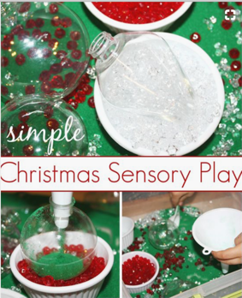 | A Christmas Sensory Bin can be made at home with items have at home or can get at the Dollar Tree. This one consists of green sand, a plastic Christmas ornament, plastic jewels, a funnel and spoon. The children love filling the ornament over and over again. You could use salt or sugar instead of sand. A plastic water bottle instead of the ornament. M&M’s or Skittles instead of jewels. The options are endless.

