Standard Focus | Activity | Home Extension Activity
I Physical Development.  d. Feeding and nutrition. 1. Responds to feeding or feeds self with increasing efficiency and demonstrates increasing interest in eating habits a making food choice.  Benchmark shows interest in new foods that are offered. | Class Activity:  The children will be having fun with food. We will organize together a banana treat. It is called “Kittens gone bananas” cut up bananas that look like kittens. “meow- | Home Activity:  Making food fun is a great way to  introduce and promote interest in good eating habits.  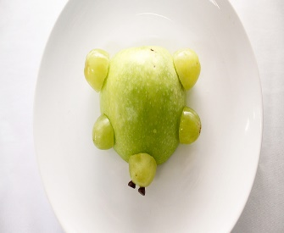  Apple Turtle  Apple and grapes
I Physical Development.  d. Feeding and nutrition. 1. Responds to feeding or feeds self with increasing efficiency and demonstrates increasing interest in eating habits a making food choice.  Benchmark shows interest in new foods that are offered. | Class Activity:  The children will be having fun with food. We will organize together a banana treat. It is called “Kittens gone bananas” cut up bananas that look like kittens. | Home Activity:  Making food fun is a great way to  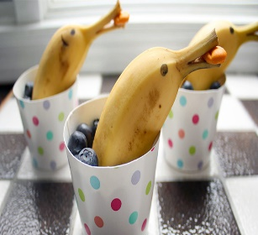  introduce and promote interest in good eating habits.  Dolphins in the Ocean:  Banana is the dolphin, Blueberries is the ocean, and goldfish.
Scientific Inquiry.  Scientific Inquiry Through Exploration and Discovery. 1. Uses senses to explore and understand their social and physical environment.  D. earth Science: Benchmark a. Explores water (e.g-plastic cups or containers in the bathtub | Class Activity:  The children will explore sensory through water outside using the different animals in the water table. | Home Activity:  Muddy Zoo Animals Toys getting washed.  Children love dirt, sand, and water.  Playing with mud is a great sensory experience and understanding our physical environment.

