Peek at Our Week

Standard Focus | Activity | Home Extension Activity
I. Physical Development  A. HEALTH AND WELLBEING  Active Physical Play  Engages in physical activities with increasing balance, coordination, endurance and intensity  B. MOTOR DEVELOPMENT  Gross Motor Development  1. Demonstrates use of large muscles for movement, position, strength and coordination  Benchmark a.  Gains control of a variety of postures and movements including stooping, going from sitting to standing, running and jumping | “The Chicken Dance”  We will be dancing with the kids outside and teaching them the chicken dance! | Dancing with your child is a great way to exercise and have fun with your child.  This is the link for the video: https://youtu.be/4xmV5uHWNag
c. Fine Motor Development  1. Demonstrates increasing precision, strength, coordination and efficiency when using hand muscles for play and functional tasks  Benchmark a.  Coordinates the use of hands and fingers | Lacing with lacing cards  Children will be given a lacing card with a picture of a farm animal. They will follow the pattern around the card by lacing the string in each hole until pattern is completed. | Practice lacing at home with your child. Take the laces out of a pair of shoes and teach your child how to lace.
Math: Children will be able to count and identify number sequence from one to ten. They will be able to recognize and name typical shapes and colors. | 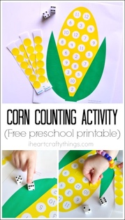  The children will be using corn kernels to sequence counting from 1-10, using the above posted game. | Using the attached sheet, you can count with your children. You may use stickers, beans, or unpopped popcorn kernels to place on each number.

