Peek at Our Week

Standard Focus | Activity | Home Extension Activity
Language and Literacy  A. LISTENING AND UNDERSTANDING  2. Increases knowledge through listening  Benchmark a.  Responds to an adult’s simple questions about what is being learned  Benchmark b.  Participates in simple conversations  Benchmark c.  Identifies specific sounds, such as animal sounds and environmental sounds | “Baa Baa Blacksheep”  Children will be learning a new song this week during circle time. | Sing or recite some of your favorite Mother Goose nursey rhymes to your child.  Baa Baa Blacksheep  Baa, baa, black sheep,  Have you any wool?  Yes sir, yes sir,  Three bags full.  One for the master,  One for the dame,  And one for the little boy  Who lives down the lane
Fine Motor Development  Demonstrates increasing precision, strength, coordination and efficiency when using hand muscles for play and functional tasks  Benchmark a.  Coordinates the use of hands and fingers | Paper Plate Sheep Art and Craft  Children will put glue onto paper plate and then place shredded paper until fully covered. Then glue on head, ears, googly eyes and legs for their own sheep. | Gather small objects such as small pompoms, beans, popcorn kernels, or seeds. As well as some paper platers or construction paper and glue. Enjoy making various art creations, while you encourage your child to strengthen their fine motor skills.
V. Mathematical Thinking  A. NUMBER SENSE  Begins to count groups of one to five objects in daily routine | Baa Baa Black Sheep Counting Cards  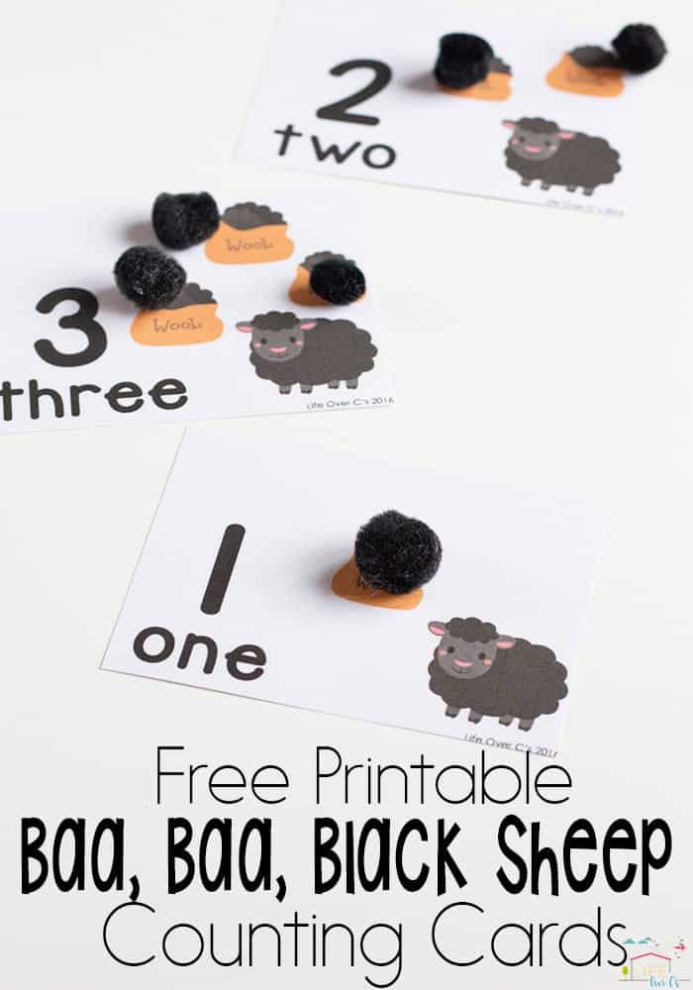 | Provide your child with purposeful counting during everyday activities. For example, ask questions such as “how many carrots are in your snack?” or “how many toy cars do you have?”  Furthermore, assist your child in counting whichever object you’ve asked about.
Parent Resource
Below is the link to a website which provides you with various fine motor skill activities that you may do at home with your child.
https://funlearningforkids.com/favorite-fine-motor-activities-preschoolers/

