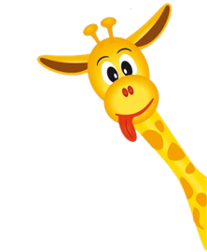
Peek at Our Week

Standard Focus | Activity | Home Extension Activity
A. EAGERNESS AND CURIOSITY  1. Shows increased curiosity and is eager to learn new things and have new experiences | In our morning circle we will discuss what a tower is and why a pier would hold a bridge up? | Watch a video about what a tower is and why a pier would hold a bridge up? https://youtu.be/oVOnRPefcno
A. SENSORY ART EXPERIENCE  1. Combines with intention a variety of open-ended, process-oriented and diverse art materials | Water table: We will add tongue depressors and small cups to build a tower. I will add tack for the children to use to keep the tower stable while the children build their tower in the water table. | 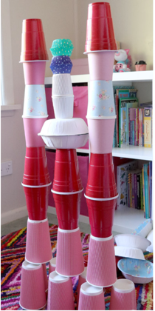  Stack bowls and paper plates to make a tower.  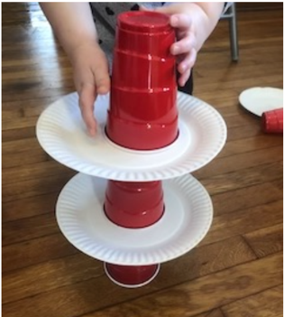
F. ENGINEERING AND TECHNOLOGY  Benchmark d.  Invents and constructs simple objects or more complex structures and investigates concepts of motion and stability of structures (e.g., ramps, pathways, structure, Legos, block building and play) | Let the children experiment with the MagnaTiles and build a tower that will not knock down. What can we use to make the MagnaTiles stable so they will not knock down? | Use empty boxes such as soda boxes, snack boxes and build a tower. Ask your child, “What can we find around the house that will make the tower stable enough to not be knocked down?”

Parent Resources: The Faith Formation for this unit is Fruits of the Spirit with this week’s focus on Peace.

