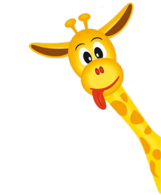
Peek at Our Week

Standard Focus | Activity | Home Extension Activity
c. Fine Motor Development  Benchmark a.  2. Increasingly coordinates hand and eye movements to perform a variety of actions with increasing precision | Give the children pipe cleaners and straws to build a structure.  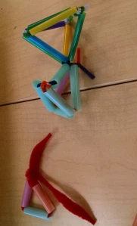 | Build a fort with blankets and pillows.
A. SENSORY ART EXPERIENCE  1. Combines with intention a variety of open-ended, process-oriented and diverse art materials | Build an igloo with sugar cubes and icing.  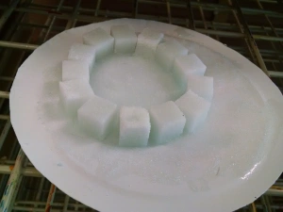 | Create a teepee out of sticks and cloth like some Native Americans tribes did.  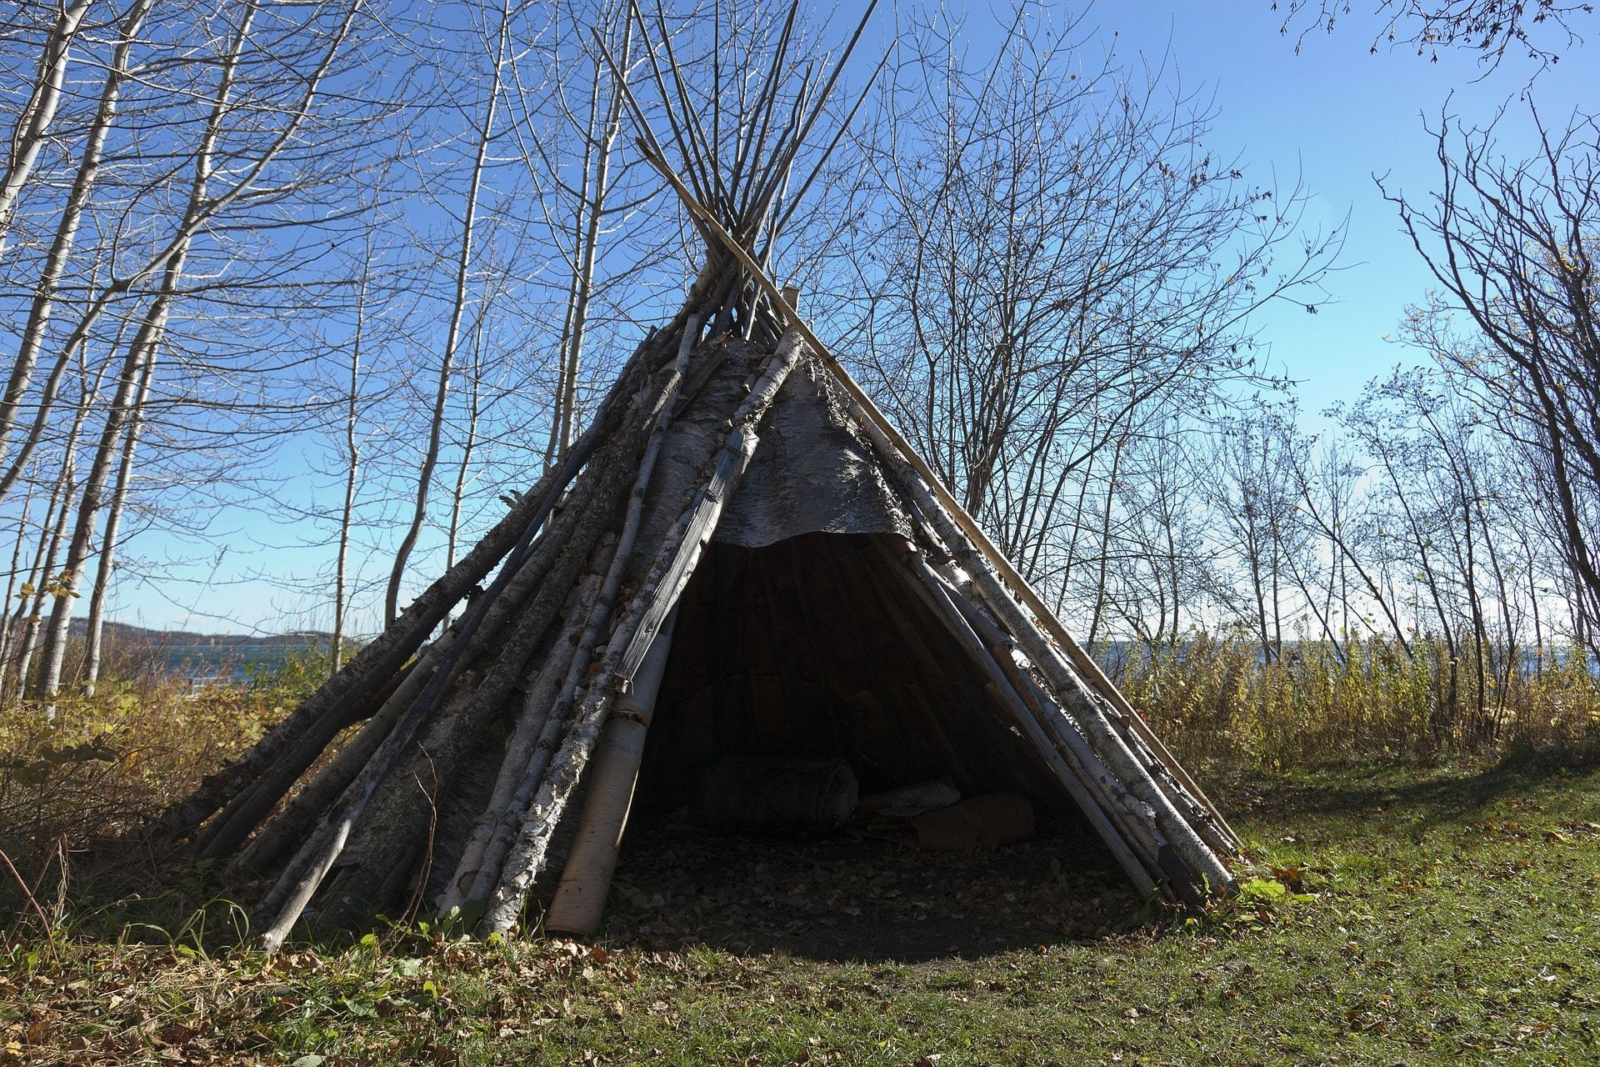
c. Fine Motor Development  Benchmark a.  2. Increasingly coordinates hand and eye movements to perform a variety of actions with increasing precision | The children will use Lincoln logs to make a structure. | At home you can use pretzels and grapes to make a structure.
Parent's Resources: The Faith Formation for this unit is Fruits of the Spirit with this week’s focus on Joy.

