Peek at Our Week

Standard Focus | Activity | Home Extension Activity
V. Mathematical Thinking  C. PATTERNS  1. Identifies and extends a simple AB repeating pattern. | Tape out a pattern on the floor to match the blocks to the pattern. | Almost anything you have at home can be used to practice patterns. Socks, cars, blocks, silverware are some examples of the items you can use at home to practice patterning. Begin a pattern fork, spoon, spoon, fork, spoon, then let your child continue the pattern.
c. Fine Motor Development  Benchmark a.  2. Increasingly coordinates hand and eye movements to perform a variety of actions with increasing precision | 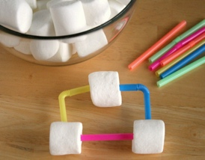  As a class we are building a structure that will consist of marshmallows and straws. | 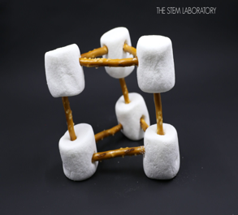  At home with your child can build a structure that is made of pretzels and marshmallows
F. ENGINEERING AND TECHNOLOGY  Benchmark d.  Invents and constructs simple objects or more complex structures and investigates concepts of motion and stability of structures (e.g., ramps, pathways, structure, Legos, block building and play) | Build a structure with different size Legos. Ask the children what do you think we can use to make this structure stable so it will not knock down if we ran a car into it? | Using any items, you have at home such as paper plates, plastic cups, popsicle sticks, water bottles, boxes, and straws. Try to build the tallest structure you can.

Parent's Resources: The children will develop their fine motor skills, problem solving skills, planning skills, and creativity by building different structures. They will practice ways to manage their frustration and demonstrate persistence while building. The Faith Formation for this unit is Fruits of the Spirit with this week’s focus on Love.

