Peek at Our Week

Standard Focus | Activity | Home Extension Activity
VII. Social Studies  C. Individuals and Groups  1. Identifies differences and similarities of self and others as part of a group. | Class Activity:  Children can understand how we are the same and different. The children will play different games that children play from other parts of the world.  - Statues- Greece  - Pass the Parcel- United Kingdom  - Tombola-Italy | Discuss the different places in the world.  Home Activity:  Share an international song  YouTube: “French Greetings for Children”
VII. Social Studies  A. CULTURE  1. Identifies characteristics of self as an individual | Ephesians 2:10: “For we are his workmanship, created in Christ Jesus for his good works, which God prepared beforehand, that we should walk in them.”  God made all of us unique. We are his workmanship.  Class Activity:  The children will have a variety of art materials to make unique art, self or any workmanship. I will include different shapes and colors of faces, colored yarn and eyes for children to create there self in a unique way. | Let us talk to children about how unique they are.  Home Activity:  Read Aloud Book.  YouTube: “Same-Same but, different”  .
III. Social and Emotional Development  A. EMOTIONAL FUNCTIONING  Shows enjoyment in interactions with trusted adults while also demonstrating skill in separating from these adults | 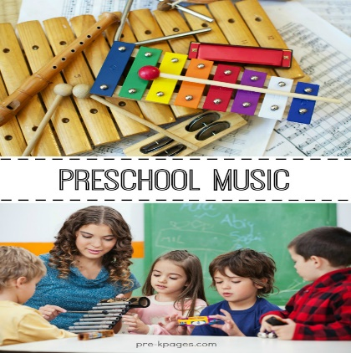  Teacher lead activities.  Children independence.  Class Activity:  The Children will have the freedom to express themselves with what they have learned. Christmas around the world is the study of how Christmas is practiced in other countries. We will explore music, language, Arts and international stories. The children will make their own musical instrument that resembles an instrument from another country. We will use different boxes, bells and rubber bands to make this project. The children will then compare their instruments with the other children’s instruments in the classroom. | Home Activity:  YouTube: Musical Instruments from around the world”

Parent Resources: YouTube: “French Greetings for Children”, YouTube: “Same-Same but, different”, YouTube: Musical Instruments from around the world”

