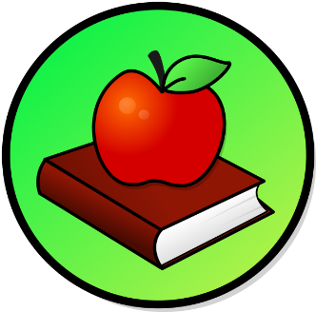
This Photo by Unknown Author is licensed under CC BY-SA
This Photo by Unknown Author is licensed under CC BY-SA

WEEKLY PEEK
Standard | Activity | At Home Extension
Physical Education Standard: PE.1. L. E Participate Regularly in physical activity. | Physical Exercise Activity: Go for a bike ride with your family in your neighborhood or the park. | Go to the Website: Verywellfamily.com
Art Standard: VA.K. S Skills, Technique, and Process. | Art Activity: How to make your own Treasure Box. | Go to the Website: https://housefulofhandmade.com
Reading Standard: LAFS.K.RL.4 Range of Reading Level and of Text Complexity. | Reading Activity: Read in your Bible about The Fruit of the Spirit “Joy.” | Go to your Bible and find the book of Galatians Chapter 5 and read about “Joy” and what it means.

