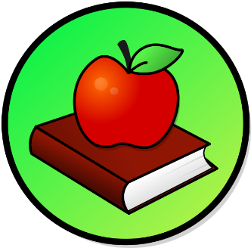
This Photo by Unknown Author is licensed under CC BY-SA
This Photo by Unknown Author is licensed under CC BY-SA

WEEKLY PEEK
Standard | Activity | At Home Extension
Reading Standard: LAFS.K.RL.4 Range of Reading Level and of Text Complexity. | Reading Activity: Read in your Bible about The Fruit of the Spirit “Love.” | Go to your Bible and find the book of Galatians Chapter 5 and read about Love.
Nature of Science: SC. 2. N.1.1. Raise questions about the natural world, investigate. | Science Activity: Go outside with your family and plant your own small garden and keep track of it all Summer. | Go to the Website: homesciencetools.com
Social Studies Standard:  S.S.1. A.1.2. Understand how to use the media and other sources to learn about historic places. | History Activity: Virtual Field Trip online to The State Capital of Washington DC. | Go to the Website: https://virtualfieldtrips.org> Washington DC

