Peek at Our Week

Standard Focus | Activity | Home Extension Activity
VIII. Creative Expression Through the Arts  A. SENSORY ART EXPERIENCE  1. Combines with intention a variety of open-ended, process-oriented and diverse art materials | Make Bluebirds using paper plates, blue tissue, and blue feathers.  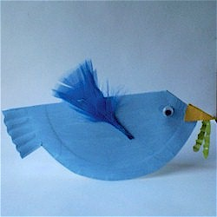 | Blue Fingerpaint  3 cups flour  2 TBSP liquid soap  3/4 cup water  Blue food coloring  * Mix all ingredients together
V. Mathematical Thinking  C. PATTERNS  1. Identifies and extends a simple AB repeating pattern  2. Duplicates a simple AB pattern using different objects  3. Recognizes the unit of repeat of a more complex pattern and extends the pattern (e.g., ABB or ABC) | Blue Noodle Necklace:  Dye blue pasta and have children string on blue yarn. | Dye pasta:  2 c. pasta  ¼ c. rubbing alcohol  1 tbsp blue dye  Place pasta in a zip loc bag with ingredients and shake. Place pasta on paper towels to dry.
E. APPRECIATION OF THE ARTS  1. Uses appropriate art vocabulary to describe own art creations and those of others  2. Compares own art to similar art forms | Interpretation painting of Van Gogh  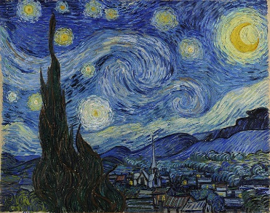  This Photo by Unknown Author is licensed under CC BY  This Photo by Unknown Author is licensed under CC BY-ND | Enjoy exploring various artists and their work. Show your child Van Gogh’s Starry Night.

Parent Resources:

Other News: No VPK Monday, January 18 in observance of Martin Luther King Jr. Day.

Thank you!

