Peek at Our Week
Standard Focus | Activity | Home Extension Activity
I. Physical Development  d. Feeding and Nutrition Benchmark a. Assists adults in preparing simple foods to serve to self or others. Benchmark b.  Recognizes nutritious food choices and healthy eating habits | 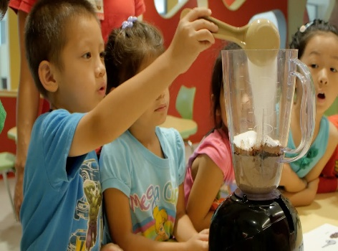  Children learn nutrition and math and science skills through food. | Cook with children. It is a great way for conversations. Children learn through creative expressions, science, and math.
II. Approaches to Learning  A. EAGERNESS AND CURIOSITY  1. Shows increased curiosity and is eager to learn new things and have new experiences  C. CREATIVITY AND INVENTIVENESS  1. Approaches daily activities with creativity and inventiveness | 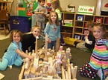  Children learn many skills through eagerness. | Encourage children to never give up on any desires or tasks. Persistence is the key to mastery of a new skill or knowledge.
III. Social and Emotional Development  2. Demonstrates appropriate affect (emotional response) between behavior and facial expression | 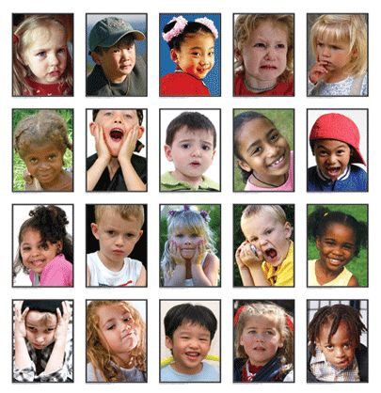  Children learn different behaviors and emotions. They learn that feelings are normal and, that Self-control is important. | Speak with children about their feelings. Let them know it is ok to express their feelings in positive ways. It is also, very important for children to have self-control of any negative feelings.

Parent Resources: Yellow Week! The children will explore the primary color Yellow!! Friday is Yellow Shirt Day!! (Wear yellow all week if possible!)

Questions to ask…. What do you see that is yellow?
How does Yellow make you feel?
What food items are yellow?
What food item labels are in your cabinets?

