Peek at Our Week

Standard Focus | Activity | Home Extension Activity
II. Approaches to Learning  A. EAGERNESS AND CURIOSITY  1. Shows increased curiosity and is eager to learn new things and have new experiences | 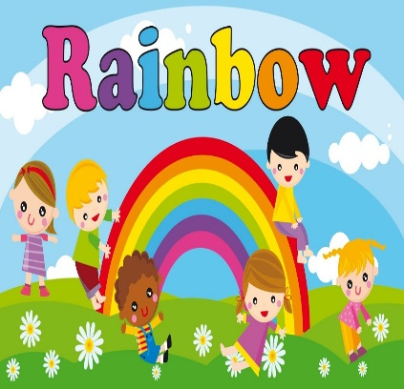  Children learn many new ideas and concepts in extended and expanded forms. | Talk to children about the Rainbow. The Rainbow is God’s promise that the earth will never flood again.
VIII. Creative Expression Through the Arts  E. APPRECIATION OF THE ARTS  1. Uses appropriate art vocabulary to describe own art creations and those of others | 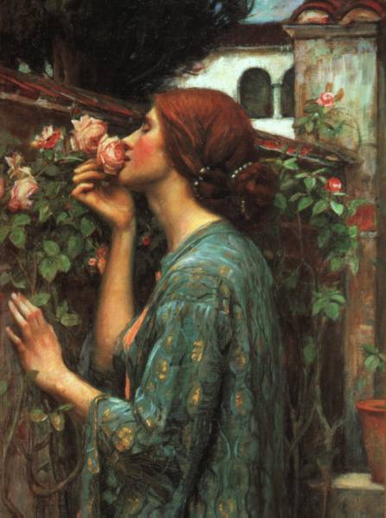  Children learn the details of art. The colors, styles, and methods of art. | Explain to children the uniqueness of art. The many methods and colors.
d. Feeding and Nutrition  Benchmark a.  Assists adults in preparing simple foods to serve to self or others  Benchmark b.  Recognizes nutritious food choices and healthy eating habits | 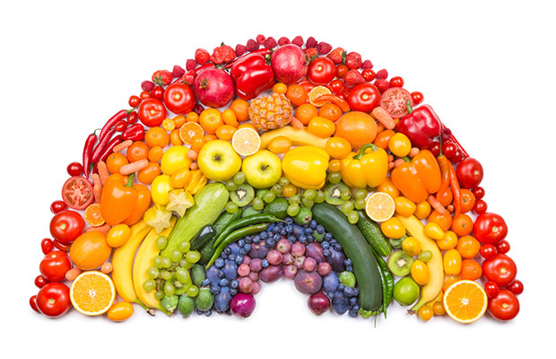  Children learn nutrition through food colors. They learn the colors of the rainbow. | Discuss with children the colors in the color wheel. The different kinds of fruits and vegetables and their colors.

Parent Resources:

Other News:

