Peek at Our Week

Standard Focus | Activity | Home Extension Activity
Faith Formation  Develops a sense of awe and wonder, respect, gratitude and stewardship for God’s creation. | Children learn that prayer is talking to God. | Pray with everyone in your house. Children love to see their family praying together.
Safe Environment Standards  SECD:1e It is alright to say “NO”. | Children learn that it is ok to say no to uncomfortable situations. | Talk to children about comfortable and uncomfortable situations.
Standard 3- Behavioral Development  SEBD: 3c How friends treat each other with respect. (Treating friends with respect builds character. The Character Kids.) | 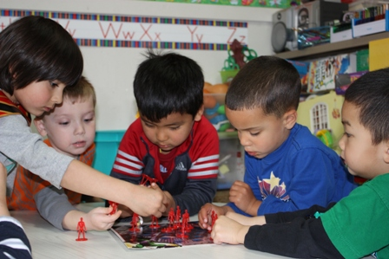  Children learn to respect each other. | Discuss with children about respecting one another.

Parent Resources:

Other News:

