Peek at Our Week

Standard Focus | Activity | Home Extension Activity
VIII. Creative Expression Through the Arts  E. APPRECIATION OF THE ARTS  1. Uses appropriate art vocabulary to describe own art creations and those of others  2. Compares own art to similar art forms | 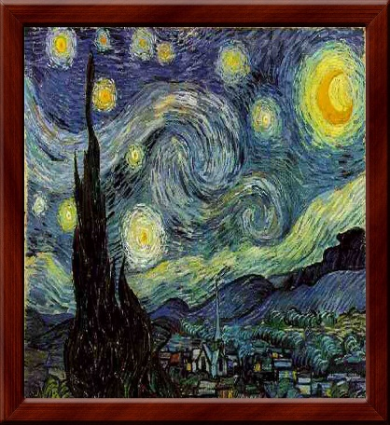  Children learn different styles of art and art forms. | Talk about different art form with children. Visit Museums together. Engage in art with children at home.
VII. Social Studies  2. Identifies differences and similarities between own environment and other locations  3. Identifies differences and similarities of basic physical characteristics (e.g., landmarks or land features) | 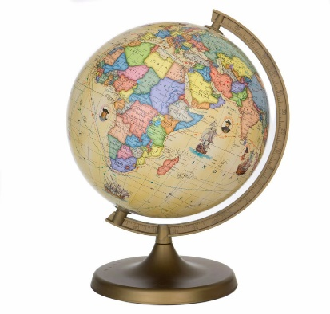  Children learn about the world and all its wonder and uniqueness. | Discuss the world with children. All the places, oceans, Rivers and Mountains. Talk about cultures and languages and the different kinds of people.
VI. Scientific Inquiry  Benchmark c.  Begins to form conclusions and construct explanations (e.g., What do the results mean?)  Benchmark d.  Shares findings and outcomes of experiments | 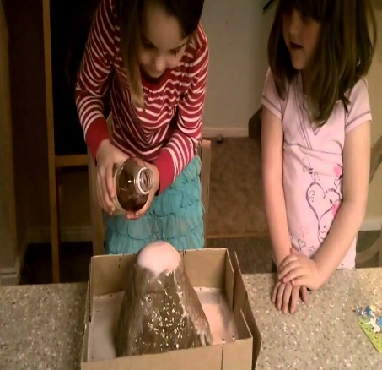  Children learn  Science through experimenting. | Do science projects and experiments at home.

Parent Resources:

Other News:

