Peek at Our Week

Standard Focus | Activity | Home Extension Activity
III. Social and Emotional Development  2. Demonstrates appropriate affect (emotional response) between behavior and facial expression | 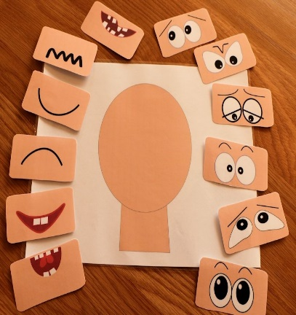  Children continue to learn many emotions. | Continue to talk to children about different emotions.
III. Social and Emotional Development  Maintains friendships and is able, to engage in prosocial behavior such as cooperating, compromising and turn-taking | 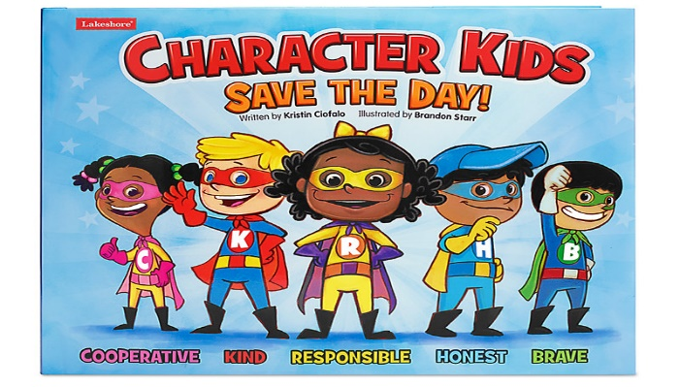  Children continue learning about character, compromising, cooperation, and taking turns with others. | Continue talking to children about character.  Taking turns, and compromising.
III. Social and Emotional Development  Uses words to demonstrate knowledge of personal information (e.g., hair color, age, gender, or size) | 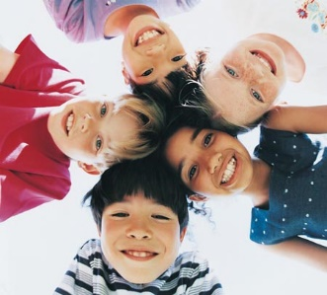  Children understand how we are the same and different. | Discuss often how we are the same and different but, all special to God.

Parent Resources:

Other News:

