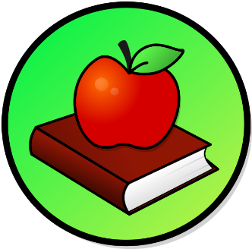
This Photo by Unknown Author is licensed under CC BY-SA
This Photo by Unknown Author is licensed under CC BY-SA

WEEKLY PEEK
Standard | Activity | At Home Extension
Reading Standard: LAFS.K12. R.1 Reading Key ideas and examining Details. | Reading Activity: Read a about plants and flowers and learn how they grow and what it takes to take care of them. | Go to the Website: flowerpowerdaily.com
Science Standard: SC.K. N Nature of Science | Science Experiment: Changing Flowers: Use any kind of light flower put it in a clear glass with water, pick out a color of food coloring and put the flower in it. (watch it change colors day by day). | Go to the Website: funlarningforkids.com
Art Standard: VA.K. S Skills, Technique, and Process. | Art Project: Make Origami Birds using any kind and any color paper. | Go to the Website: origami.guide>origami animals

Parent Resources and Information

