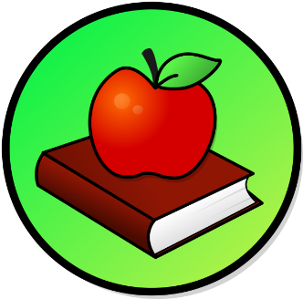
This Photo by Unknown Author is licensed under CC BY-SA
This Photo by Unknown Author is licensed under CC BY-SA

WEEKLY PEEK
Standard | Activity | At Home Extension
Health Standard: CTE.AFNR.68. FOOD.05 Demonstrate knowledge & skills in food science. | Cooking Activity: Earth Snacks: Make a fruit bowl full of grapes, blueberries, bananas, and strawberries. | Go to the Website: theeducatorsspinonit.com
Reading Standard: LAFS.K12. R.1 Reading Key ideas and examining Details. | Reading Activity: Pick a book on the earth and read about it and learn what life on earth is and what it means to you. | Go to the Website: Schoolasticbooks.com or go to the library or your favorite local bookstore.
Physical Education Standard: PE.1. L. E Participate Regularly in physical activity. | Physical Activity: Do kids Yoga inside or outside. | Go to the Website: Cosmickids.com

Parent Resources and Information

