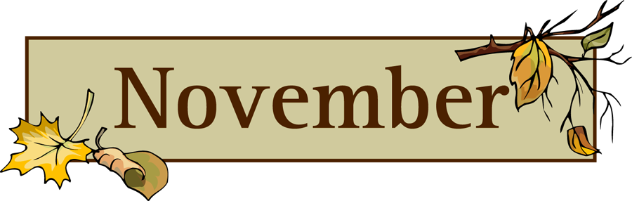
VPK 2 November News
Dear Parents/ Grandparents/Guardians
Peace and Love of Jesus Christ be with you all!
We are very glad to inform you that your children are getting used to the class room rules, daily schedules and routines.
October was a very fun, exciting and tangible learning month for our children. Thanks a lot to the parents who came to our School with your uniform, working tools, vehicles and explaining to the children about the use of those things and making the children to understand your particular role as a Community Helper. God’s blessings to you all for your generosity!
Our Study Topics for this month include: All Saints Day, All Souls Day, Fall Leaves, All about Family and Thanks Giving.
November 1 is a special day called the feast of All Saints. It is the day the Church celebrates with all the people who have died and are now with God in heaven. We will discuss about Saint Mother Theresa of Calcutta (whom I know personally) who loved Jesus so much and shared His love with others. She use to say, ”Do small things for others with great love for Jesus”. We will be learning to do small things for others with great love for Jesus.
All Souls' Day is observed on November 2, and is dedicated to those who have died and not yet reached heaven. We remember all our departed dear ones and pray for them. You are most welcome to bring a picture of any of your departed dear ones to our class.
We will be discussing Fall Leaves and their color changes from green to red, orange, yellow and brown. We will learn what happens to them when they fall of the tree? We read Stories, sing songs, count leaves, decorate leaves and Sought out the leaves by color and size.
We will be talking about our Family and Thanksgiving. We will discuss who is in our families and how do we celebrate Thanks giving with our family members. We will be reading many stories about Thanksgiving and other learning activities such as Thanksgiving songs, art, patterning and we will discuss about what we are thankful for, such as our family members, friends, school etc.
We will be learning making pattern and continue our study of the Math activities for building number sense to 1-20, Learning Alphabet letter, sound and we brainstorm to find the words that begin with that letter .
Please help us what we need for our weekly cooking experiences and with our monthly snack donation. We greatly appreciate all you do, to support our classroom and may God bless you for your generosity.

Please remember to come on November 16Th for our Thanksgiving Soup luncheon and please dress your child with his/her sports team shirt on 16Th when they come to school.
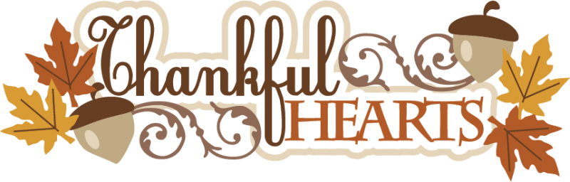
We wish you a very happy Thanksgiving and God’s abundant Blessings!
Sr. Elizabeth & Ms. Krystal

