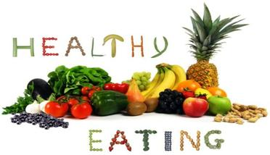
Learning to eat healthy food and make choices to live a healthy lifestyle starts now. Our classes will have food preparation and tasting experiences in addition to their regular lunches. We encourage the children to try new and interesting foods, flavors and textures throughout the year. Some great snack donation ideas each month are as follows.
100% juice or milk
Fresh fruits – apples, grapes, bananas, kiwi, strawberries, peaches, oranges, etc.
Fresh Vegetables- cherry tomatoes, broccoli, cauliflower, celery, carrots, cucumbers, etc.
Cheese- cheese sticks, cheese blocks, cheese slices and cubes, cottage cheese, cream cheese
Ham and Turkey slices
Yogurt
Applesauce
Cheerios, Rice Krispies, Mini Shredded Wheat, Kix, Raisin Bran
Cereal bars
Crackers – any kind
Pretzels
Goldfish
Fig Newton’s
Bagels, bread

Please remember that we are a peanut and tree nut free school.

